

Mobile Programming

GreenyDroid

MI141

Heramia, Johanna Marisse C.  
Tadeo, Jose Lorenzo G.

Professor: Mr. Noel Anonas

**Table of Contents**

Description………………………………………………………………...3

Target Audience……………………………………………………….….3

Project Objective………………………………………………………….3

Scope and Limitation………………………………………....................3

Review of Related Literature…………………………………………….4

Game Mechanics……………………………………………………...….5

Game Instruction………………………………………………………….5

Game Map / Level………………………………………………………...6

Technologies used……………………………………………………….11

Use Case Diagram……………………………………………………….11

Activity Diagram………………………………………………………….12

Java Code Snippets……………………………………………………..14

Graphics Assets and Art Work Example………………………………19

Glossary of Terms

Lessons Learned………………………………………………...………20

Resume of each member……………………………………………….21

**GREENYDROID**

**Theme:** *Health /* Game

*GreenyDroid* is a game application that allows the user to know more about every version of android and simple health tips depending on the version of android. GreenyDroid has different levels from easiest level (first version) to hardest level (latest version). Every version, there is different *character* that they will be using in mini games

In order to go to the next level, the user needs to do the challenges correctly, but if the user cannot do the challenges, they will repeat the challenge from the beginning of their current level. Challenges are composed of questions (multiple choice) and mini games (at least five mini games) that should be answered and played by the user.

The target audience are people from 7-18 years old for they will be able to understand the game easily and playfully. Seven years old below and 18 and above may use it for their entertainment.

The main objective of this project is to be able to know more about the super simple details in every version of android, to be able to give information for the user to be more knowledgeable in certain food and to give user the *entertainment*.

The features that are included:

* Different feature of character in every level
* Story in every level
* Questions from the story with choices
* Mini games
* Health tips / information that are connected on the characters or level

Features that are NOT included:

* User can’t create their own character
* User can’t change the name of the character
* Health tips are just simple and few

**Review of Related Literature**

*Category Quiz (Trivia)* Category Quiz is a quiz where the questions must be answered by category such as sports, entertainment, food, geography, music, news etc. If all questions in a category are answered correctly, user will get and extra points, but if question is answered incorrectly, the category gets locked. If the question timer is used (can be enabled/disabled using the game options) the user has 30 seconds to answer the question. Like on our project, it also has question and answer portion that needs to be answered correctly in every level of the game but the user cannot disable nor enable the timer of the game.

*Nutrition Tips* This application, like on our application, gives useful nutrition tips and nutritional health facts that can help to and improve a person’s health.

*Pou* Pou is a pet that you can take care of, like user should give food, give shower, give good outfit, and give some fun. It has mini games that user should play to earn money to buy items and to earn level to unlock items.

**Game Mechanics**

Before the game will start, an instruction will be given to be able to know the objective of the challenge on each level. Stories will be given and user should read it and understand it carefully and quickly because stories have time limit. After the story, certain question will be asked and questions should be answered quickly to do the challenge. When the questions are answered correctly, the user will be able to go the next activity, which is the mini game. Before the mini game, an instruction will be given and the user should complete the requirements. Everything must be completed to be able to go to the next level.

**Game Instruction**

In question and answer, click the corresponding button for the correct answer. User should get three correct answers to be able to go to the next activity, otherwise, new sets of questions will be asked. Since the user cannot go back to the story, he/she should understand it very carefully. In mini games, to be able to move the character, touch the screen on the left side, if you want to move the character on the left and touch the screen on the right if you want to move the character on the right side.

**Technical Requirements**

The technologies or software that we used to develop this application are: (1) Android Studio. Android Studio provides the fastest tools for building apps on every type of Android device. We use Android Studio for code editing, debugging, performance tooling, a flexible build system, and an instant build/deploy system. (2) Also, we use Photoshop for creating image and Word Document for creating background.

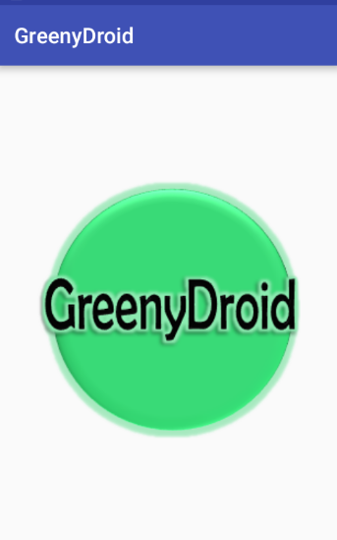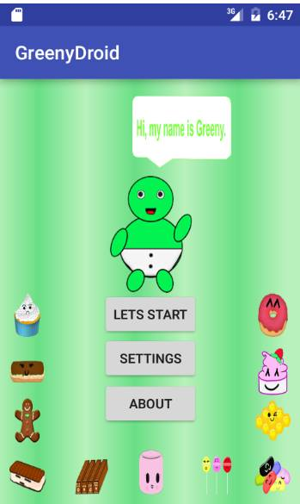**Game Map**

WELCOME SCREEN  
 This is the welcome screen of the application. While loading, the GreenyDroid logo will turn around.

MAIN PAGE  
 This is the main page of the application. There are three buttons: LET’S START, SETTING, and ABOUT.

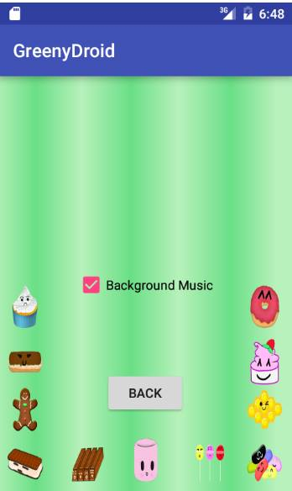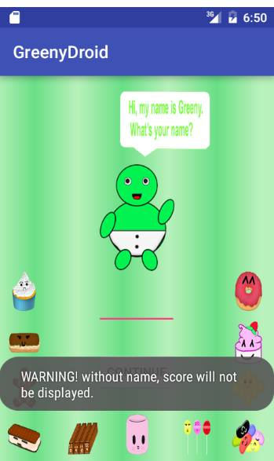

SETTING SCREEN  
 When the user clicks the ‘Setting’ button, it will display a screen where the user may turn on or off the background music

GET NAME SCREEN  
 When the user clicks the ‘Let’s start’ button, it will display a screen where the user should put his/her name.

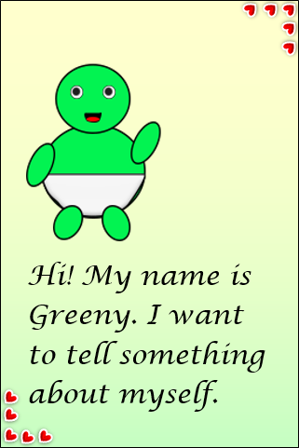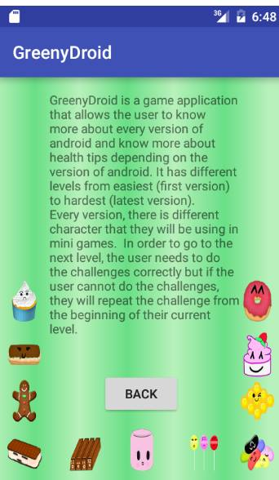

BEGIN

INTRODUCTION SCREEN  
 After the user enters his/her name, there are introduction / instruction before the story.

ABOUT SCREEN  
 When the user clicks the ‘Let’s start’ button, it will display a screen where the user should put his/her name.

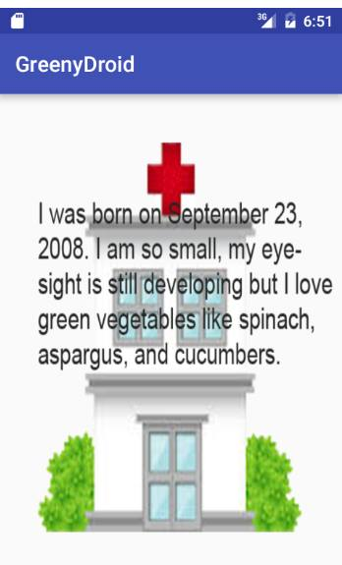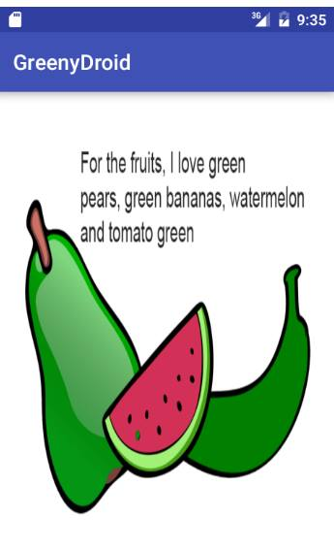

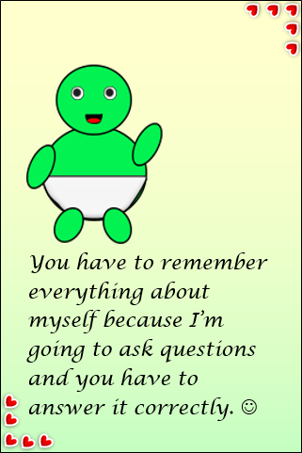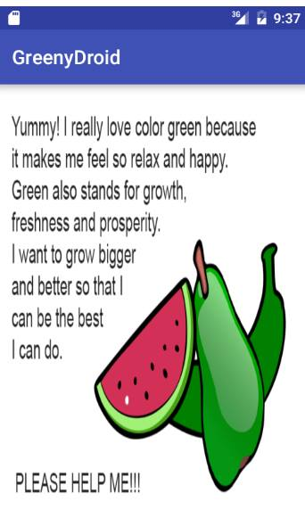

STORY  
 When the user clicks the ‘Begin’ button, it will display the story.

BEGIN

INTRO  
 Intro before the questions

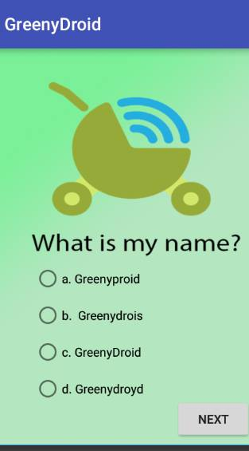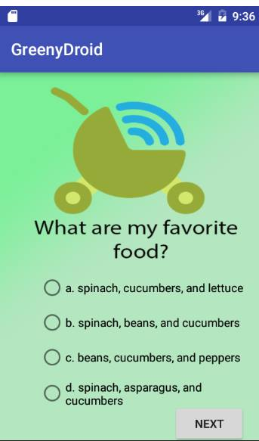

QUESTIONS  
 This is the questions that are related to the story that the user should answer correctly

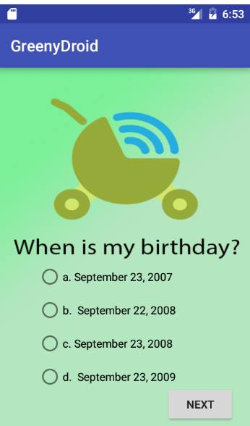

NEXT

RETRY

RESULT PAGE  
 This is the questions that are related to the story that the user should answer correctly

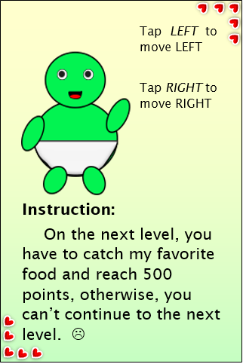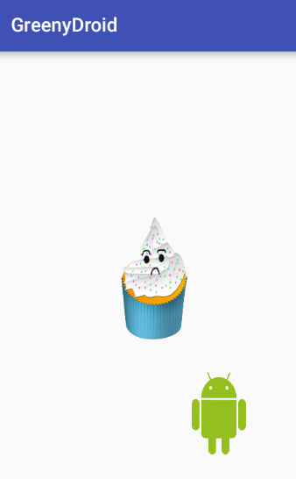

INSTRUCTION  
 This is the instruction before the mini game.

MINI GAME  
 This is the mini game after the questions.

BEGIN

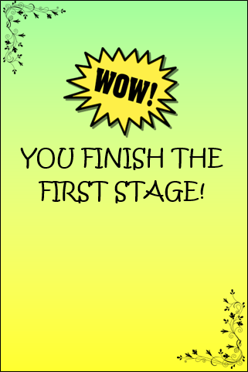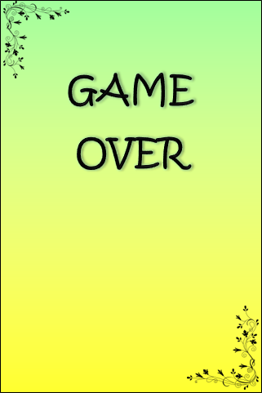

GAME OVER  
 This game over screen will display when the user was not able to do the mini game, requirement

FINISH SCREEN  
 This finish screen will display when the user was able to complete first level of the game.

MENU

RETRY

**Technical Requirements**

The technologies or software that we used to develop this application are: (1) Android Studio. Android Studio provides the fastest tools for building apps on every type of Android device. We use Android Studio for code editing, debugging, performance tooling, a flexible build system, and an instant build/deploy system. (2) Also, we use Photoshop for creating image and Word Document for creating background.

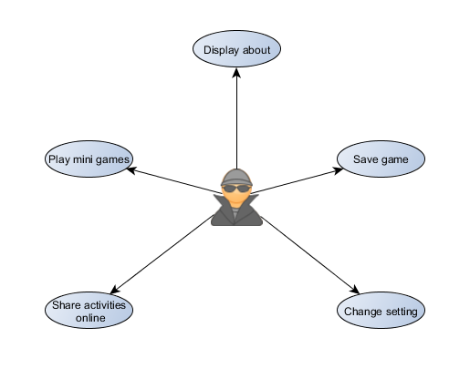USE CASE DIAGRAM

SYSTEM FLOW

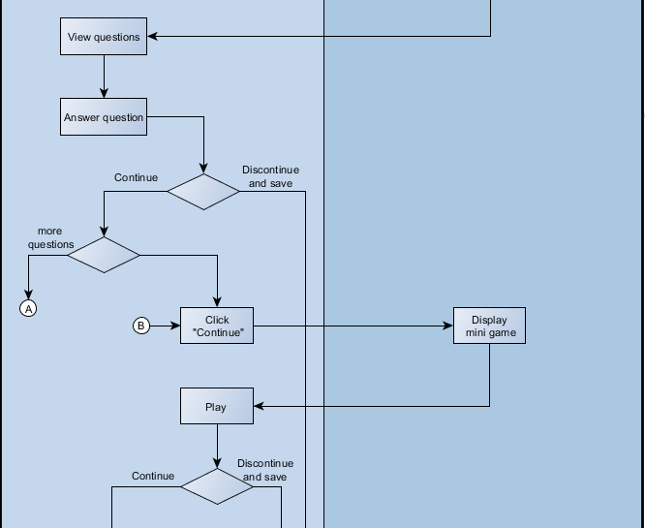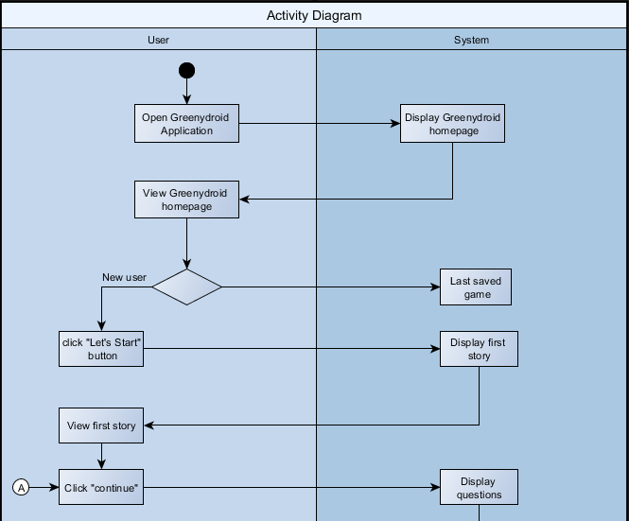

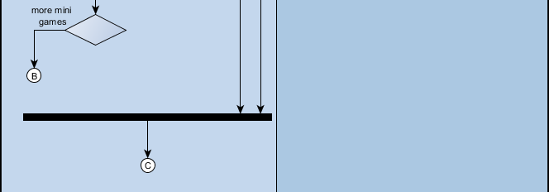

**JAVA CODES SNIPPET**

1. When button is clicked, new activity will appear.

private void settingButton() {  
 Button setting = (Button) findViewById(R.id.btnSetting);  
 setting.setOnClickListener(new View.OnClickListener() {  
 public void onClick(View v) {  
 Intent i = new Intent(MainActivity.this, SettingActivity.class);  
 startActivity(i);  
 finish();  
 }  
 });  
}

1. When user wants to go back (Back button) using shared preference

public void backButton() {  
 Button back = (Button) findViewById(R.id.btnBack);  
 back.setOnClickListener(new View.OnClickListener() {  
 public void onClick(View v) {  
 bgdCheck = 1;  
 Intent i = new Intent(SettingActivity.this, MainActivity.class);  
 startActivity(i);  
 finish();  
 SharedPreferences sp = getSharedPreferences("GreenyDroid.txt", MODE_PRIVATE);  
 SharedPreferences.Editor spsave = sp.edit();  
 spsave.commit();  
 }  
 });  
}

1. Turning on and off of music background.

public static int bgdCheck = 0;  
static CheckBox music;  
  
@Override  
protected void onCreate(@Nullable Bundle savedInstanceState) {  
 super.onCreate(savedInstanceState);  
 setContentView(R.layout.activity_setting);  
 backButton();  
  
 music = (CheckBox) findViewById(R.id.checkBox);  
 if (MainActivity.bgdMusic.isPlaying()) {  
 SettingActivity.music.setChecked(true);  
 } else {  
 SettingActivity.music.setChecked(false);  
 }  
  
 music.setOnCheckedChangeListener(new CompoundButton.OnCheckedChangeListener() {  
 public void onCheckedChanged(CompoundButton buttonView, boolean isChecked) {  
 if (isChecked) {  
 SharedPreferences.Editor editor = getSharedPreferences("GreenyDroid.txt", MODE_PRIVATE).edit();  
 editor.putBoolean("Resume", true);  
 editor.commit();  
 music.setChecked(true);  
 MainActivity.bgdMusic.start();  
 } else {  
 SharedPreferences.Editor editor = getSharedPreferences("GreenyDroid.txt", MODE_PRIVATE).edit();  
 editor.putBoolean("Pause", false);  
 editor.commit();  
 music.setChecked(false);  
 MainActivity.bgdMusic.pause();  
 }  
 }  
 });

1. Getting answer from the user using the radio button.

static RadioButton A, B, C, D;  
  
protected void onCreate(Bundle savedInstanceState) {  
 super.onCreate(savedInstanceState);  
 setContentView(R.layout.activity_acupcakequestion);  
  
 A = (RadioButton)findViewById(R.id.radioButtonA);  
 A.setOnCheckedChangeListener(new CompoundButton.OnCheckedChangeListener() {  
 @Override  
 public void onCheckedChanged(CompoundButton buttonView, boolean isChecked) {  
 if(isChecked){  
 nextButton();  
 }else{  
 nextButton();  
 }  
 }  
 });  
 B = (RadioButton)findViewById(R.id.radioButtonB);  
 B.setOnCheckedChangeListener(new CompoundButton.OnCheckedChangeListener() {  
 @Override  
 public void onCheckedChanged(CompoundButton buttonView, boolean isChecked) {  
 if(isChecked){  
 nextButton();  
 }else{  
 nextButton();  
 }  
 }  
 });  
 C = (RadioButton)findViewById(R.id.radioButtonC);  
 C.setOnCheckedChangeListener(new CompoundButton.OnCheckedChangeListener() {  
 @Override  
 public void onCheckedChanged(CompoundButton buttonView, boolean isChecked) {  
 if(isChecked){  
 SharedPreferences sp = getSharedPreferences("QuestionCupcake",MODE_PRIVATE);  
 SharedPreferences.Editor spsave = sp.edit();  
 spsave.commit();  
 nextButton();  
 }else{  
 nextButton();  
 }  
 }  
 });  
}

1. Putting delay before the fruits would drop in mini game

class Timer implements Runnable{

@Override

public void run() {

while(count != 5){

SystemClock.sleep(1000);

count++;

}

}

}

1. Displaying high score

SharedPreferences sp = getSharedPreferences("highscore.txt", MODE_PRIVATE);

lastHighScore = sp.getInt("highscorebeat", highScore);

highScore = lastHighScore;

7. Adding score

int c = 0;

String name = StartActivity.name;

if(CCupcakeQuestionActivity.D.isChecked()){

c+=1;

}

if(BCupCakeQuestionActivity.C.isChecked()){

c+=1;

}

if(ACupcakeQuestionActivity.C.isChecked()){

c+=1;

}

8. If the user’s score is equals to three, he/she may proceed to the next activity, else if less than three, user should try again.

switch(c){

case 1:

if(StartActivity.name.isEmpty()){

}else{

TextView Name = (TextView)findViewById(R.id.congratulation);

Name.setText("Try again " + name);

TextView Score = (TextView)findViewById(R.id.score);

Score.setText("" + c);

}

retryButton();

break;

case 2:

if(StartActivity.name.isEmpty()){

}else{

TextView Name = (TextView)findViewById(R.id.congratulation);

Name.setText("Almost there " + name);

TextView Score = (TextView)findViewById(R.id.score);

Score.setText("" + c);

}

retryButton();

break;

case 3:

if(StartActivity.name.isEmpty()){

}else{

TextView Name = (TextView)findViewById(R.id.congratulation);

Name.setText("Congratulation " + name);

TextView Score = (TextView)findViewById(R.id.score);

Score.setText("" + c);

}

nextButton();

break;

default:

if(StartActivity.name.isEmpty()){

}else{

TextView Name = (TextView)findViewById(R.id.congratulation);

Name.setText("Please try again " + name);

TextView Score = (TextView)findViewById(R.id.score);

Score.setText("" + c);

}

retryButton();

break;

}

**Graphics Asset and Artwork Sample**

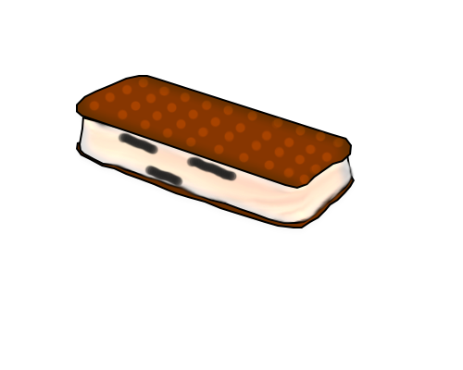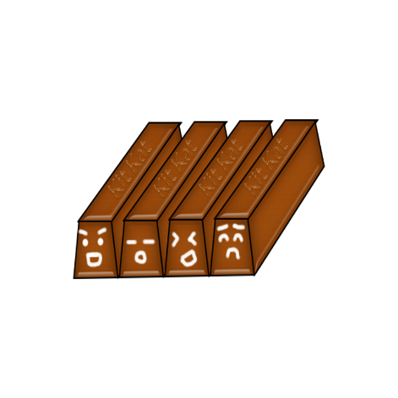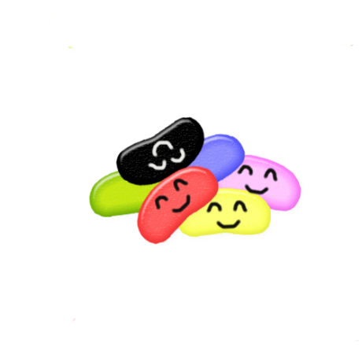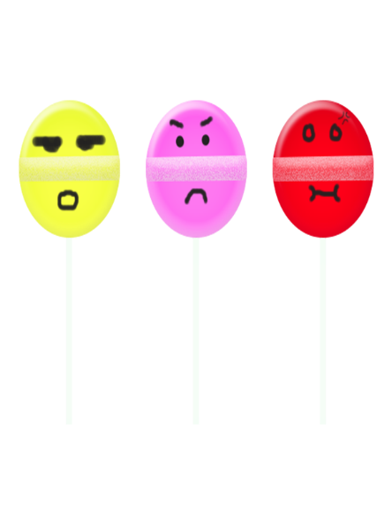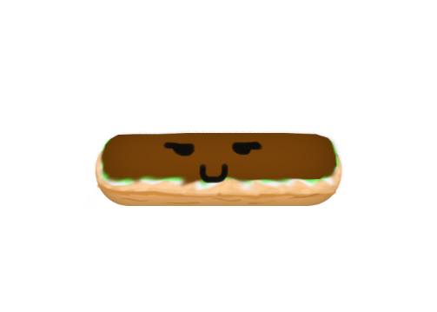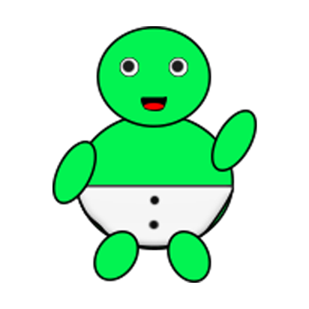

**Lesson Learned**

Having a subject like Mobile Programing requires time to learn and willingness to learn for us to be able to pass. Analyzation, memorization, and time management is one of the most important thing that every individual should learn and should have. From the start, it was not easy, but as the time goes by, you will “ENJOY”. You will enjoy learning xml codes and java codes, and even if creating image is not part of this subject, but we do not have choice but to use Photoshop (like no basic knowledge) to build characters, images and backgrounds that are needed in our application. Even if it is hard and always we get errors, when we get it, it is the best feeling in the world. No matter how hard it is, in the end, it is worth the effort.

**JOHANNA MARISSE CREDITO HERAMIA**

P 53 – 20 12th 15th St., Villamor Air Base, Pasay City

jcheramia@student.apc.edu.ph

+63926 152 3128

**EDUCATION**

June 2014 – Present Asia Pacific College

#3 Humabon Place, Magallanes, Makati City

Bachelor of Science in Information Technology

Major in Mobile and Internet Technology

June 2010 – March 2014 Pasay City South High School

Piccio Garden, Villamor Air Base Pasay City

June 2004 – March 2010 Villamor Air Base Elementary School

Piccio Garden, Villamor Air Base Pasay City

**ORGANIZATIONS**

2015-2016 Junior Philippine Computer Society

Member

2016 – Present Junior Informations System Security Association

Documentations Head

**RESEARCH PROJECT**

THE NEGATIVE EFFECTS OF COURSES CHOSEN BY PARENTS TO THE ACADEMIC PERFORMANCE OF STUDENTS IN ASIA PACIFIC COLLEGE, ACADEMIC YEAR 2015-2016

BALCENA, D.P., GARDON, J.G., HERAMIA, J.C.

**PERSONAL DATA**

December 2, 1997

Pasay City

Tagalog

Single

**JOSE LORENZO GONZALES TADEO**

8291 B. Dapitan St. Guadalupe Nuevo, Makati City

jgtadeo@student.apc.edu.ph

09354811320

**EDUCATION**

June 2014 – Present Asia Pacific College

#3 Humabon Place, Magallanes, Makati City

Bachelor of Science in Information Technology

Major in Mobile and Internet Technology

June 2010 – March 2014 Guadalupe Catholic School

1923 Orense St, Guadalupe Nuevo, Makati City

June 2006 – March 2010 Guadalupe Catholic School

1923 Orense St, Guadalupe Nuevo, Makati City

June 2004 – March 2006 Paco Catholic School

1521 Paz St, Paco, Manila

**ORGANIZATIONS**

2014 – 2015 Junior Philippine Computer Society

Member

2016 – Present Microsoft Community

Assistant Documentations Head

**RESEARCH PROJECT**

THE BENEFITS OF PHYSICAL EDUCATION TO FRESHMEN

STUDENTS WITH HEALTH PROBLEMS IN ASIA PACIFIC COLLEGE, ACADEMIC YEAR 2015 – 2016

TADEO, J, G., SAMSON, J, O., VICTORINO, M, I.

**PERSONAL DATA**

March 26, 1998

Makati City

Tagalog

Single

Revision Table

|  |  |  |
| --- | --- | --- |
| **DATE** | **TASK** |  |
| **07/26/16** | Started creating images and background | Johanna Marisse Jose Lorenso |
| **08/02/16** | Started creating the application using Android Studio | Johanna Marisse Jose Lorenzo |
| **08/02/16** | Put all the images in drawable and mipmap-hdpi | Johanna Marisse Jose Lorenzo |
| **08/02/16** | Started creating java activity and xml layouts | Johanna Marisse Jose Lorenzo |
| **08/04/16** | Started coding and connecting of activities | Jose Lorenzo |
| **08/05/16** | Coding for the setting activity for turning on and off of background music | Jose Lorenzo |
| **08/12/16** | Started animating the welcome page | Jose Lorenzo |
| **08/13/16** | Started using shared preference for the score and name | Jose Lorenzo |
| **08/13/16** | Started putting all the stories and questions with time limit | Johanna Marisse Jose Lorenzo |
| **08/13/16** | Started creating the mini game | Jose Lorenzo |
| **08/13/16** | Moving of the character | Jose Lorenzo |
| **08/18/16** | Animating falling food | Johanna Marisse Jose Lorenzo |
| **08/18/16** | Coding for the score of the mini game | Johanna Marisse Jose Lorenzo |
| **08/18/16** | Getting and Displaying High Score  Limit of the mini game | Jose Lorenzo |
| **08/18/16** | Started creating the 2nd level | Johanna Marisse Jose Lorenzo |
| **08/20/16** | Doing the mini game for the next level | Jose Lorenzo |
| **08/21/16** | Creating more background | Johanna Marisse |
| **08/23/16** | Updating Requirement | Johanna Marisse |
| **08/23/16** | Continuing the 2nd level | Jose Lorenzo |

**Requirement Checklist**

*Project Document*

|  |  |  |  |
| --- | --- | --- | --- |
| Name | TO DO | DOING | DONE |
| 1. Overview |  |  | ✓ |
| 1. If game is selected |  |  | ✓ |
| 1. Technical Requirements |  |  | ✓ |
| 1. Graphics Asset and Samples |  |  | ✓ |
| 1. Glossary of Terms |  | ✓ |  |
| 1. Lesson Learned |  |  | ✓ |
| 1. Resume of each member |  |  | ✓ |
| 1. Revision Table |  | ✓ |  |

|  |  |  |  |
| --- | --- | --- | --- |
| Name | TO DO | DOING | DONE |
| 1. Video Presentation |  | ✓ |  |
| 1. PowerPoint Presentation | ✓ |  |  |
| 1. 1 Printed Documents | ✓ |  |  |

*Project Application (GreenyDroid)*

|  |  |  |  |
| --- | --- | --- | --- |
| Name | TO DO | DOING | DONE |
| 1. Pictures |  |  | ✓ |
| 1. Background |  | ✓ |  |
| 1. Background music |  |  | ✓ |
| 1. Story (1) |  |  | ✓ |
| 1. Mini Game (1) |  |  |  |
| -Falling fruit |  |  | ✓ |
| 1. Shared Preference (name) |  |  | ✓ |
| 1. Shared Preference (high score) |  |  | ✓ |
| 1. Displaying score when playing game |  |  | ✓ |
| 1. Story (2-Cupcake) |  |  | ✓ |
| 1. Mini Game (2) |  | ✓ |  |
| -Touching fruit |  |  |  |
| 1. More mini games | ✓ |  |  |
| 1. More stories | ✓ |  |  |

*Reviewer Comments/Issues*

More stories and mini games are not yet done because we are having a hard time to focus because there are more other projects that we need to do. Also, when developing the mini game, there are syntax and logical error that is why there are delays.